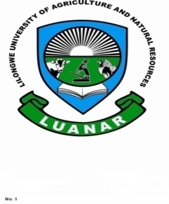

Knowledge Innovation Excellence

**GBV AND SEXUAL HARASSMENT REPORTING**

**Support and Resources**

The University supports persons affected by sexual misconduct. Support is available in many forms and is available regardless of whether you decide to submit a report or not.

Staff, students and community can report any sexual misconduct involving a LUANAR staff or student to:

Gender Coordinating Unit ([Genderunit@luanar.ac.mw](mailto:Genderunit@luanar.ac.mw) ) 0996 29 38 04

The Clinic (Bunda) 0999 27 69 01

The Clinic (NRC) 0883 52 98 92

Security Officer (Bunda) 0999 57 38 24

Security Officer (NRC) 0888 71 66 83

Victim Support Unit and Police (Bunda Police Unit and any other clinic nearby) 0888 17 22 88

**Additional support for LUANAR students include:**

Director of Student Affairs (DOSA) 0999 33 08 75

Assistant Registrar-Student Welfare (Bunda) 0999 95 33 06

Assistant Registrar-Student Welfare (NRC) 0993 86 87 93

Warden (Bunda) 0992 29 10 37

Warden (NRC) 0888 65 01 89

Housekeeper (Bunda) 0881 94 51 81

Administrative Officer (City Campus) 0999 95 53 35

Administrator (ODL) 0995 70 08 34

You may find more information about support and resources at the web site: Sexual Misconduct and Harassment Information . **If you are experiencing an emergency, or if there is imminent risk to your well-being or that of another person, contact the LUANAR hotlines**

**REPORT SEXUAL HARRASMENT TO STOP IT**